Chapter 8, Problem 19.

Obtain v(t) for t > 0 in the circuit of Fig. 8.73.

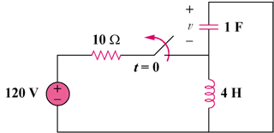

Figure 8.73
For Prob. 8.19.

